Wedge
# Source: AI Source: Provided by: [Data Path: Persons Table -> ID Column: 1, Name_En Column: Motasem Essam] -> From: [ChatGPT] on [7/25/2026]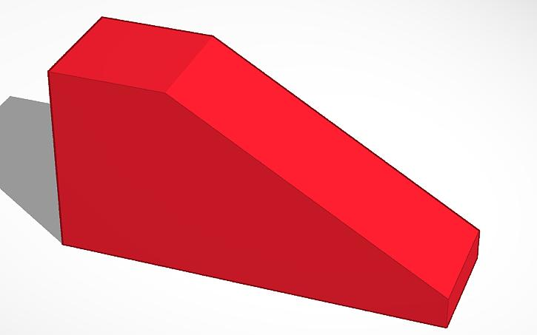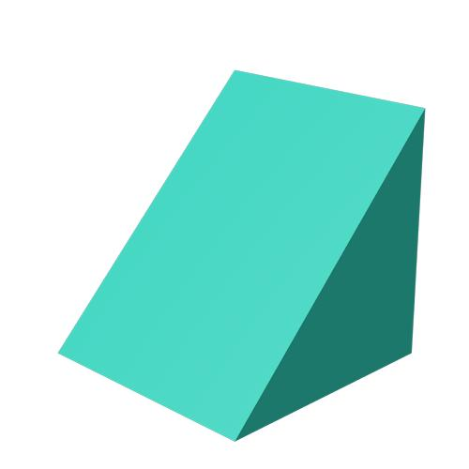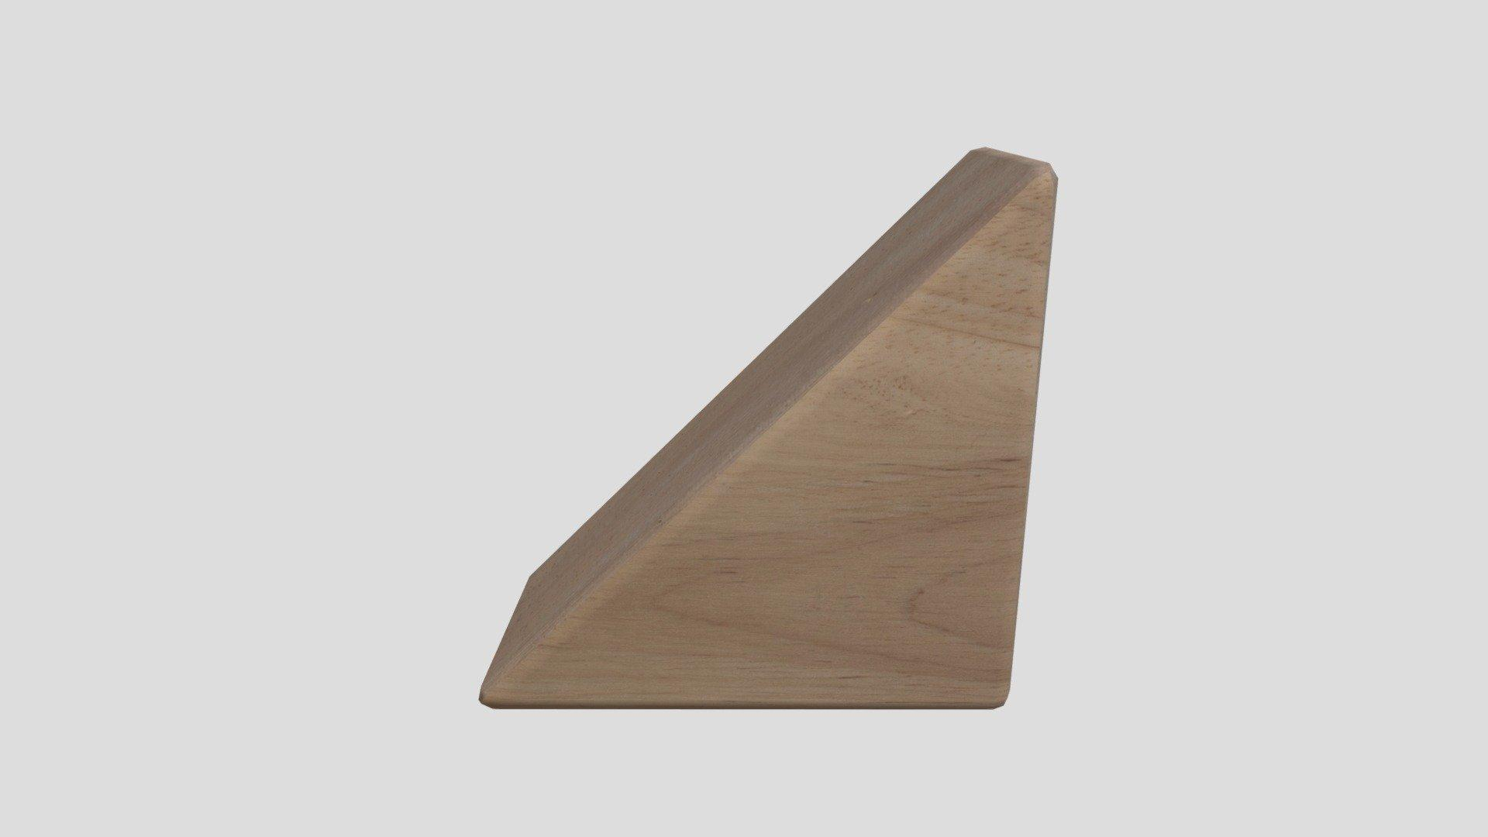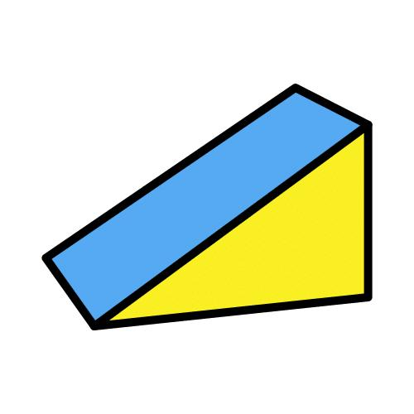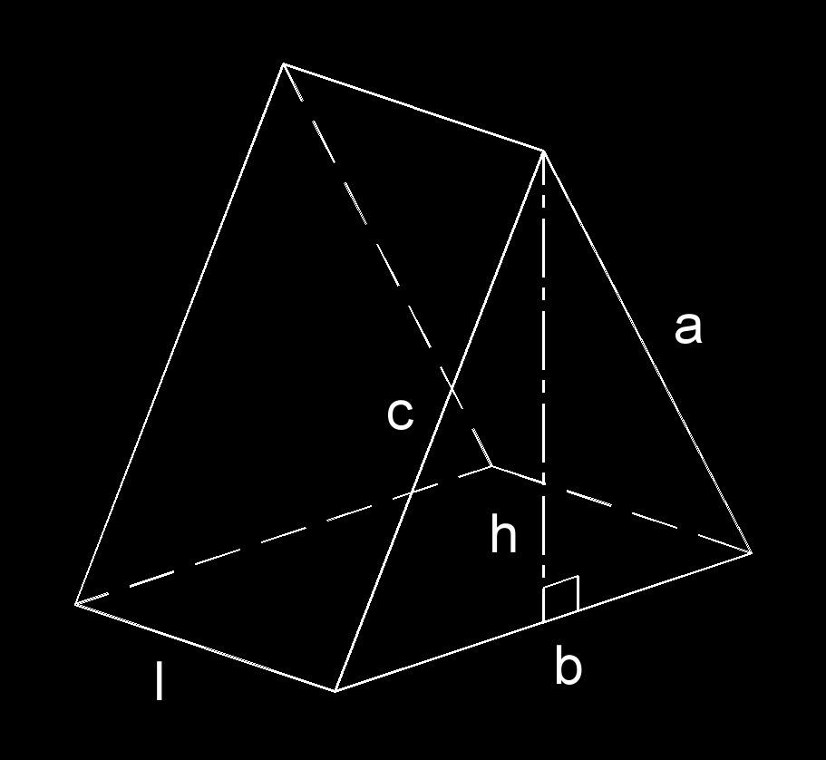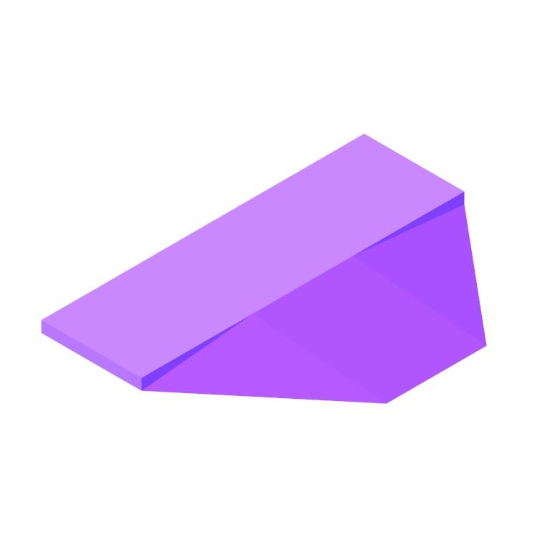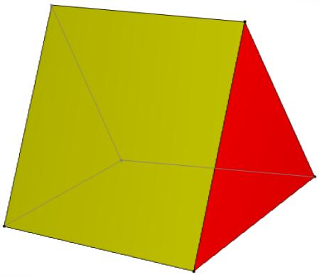

Definition
# Source: AI Source: Provided by: [Data Path: Persons Table -> ID Column: 1, Name_En Column: Motasem Essam] -> From: [ChatGPT] on [7/25/2026]
A Wedge is a three-dimensional solid characterized by a shape that gradually thickens or narrows between two opposite ends. It commonly has a triangular cross-section along one direction and may have a flat bottom, an inclined upper surface, and vertical or sloping side surfaces.
In geometry, a wedge is generally a solid bounded by a combination of flat polygonal faces. Its exact structure depends on how it is constructed.

Simple Definition
# Source: AI Source: Provided by: [Data Path: Persons Table -> ID Column: 1, Name_En Column: Motasem Essam] -> From: [ChatGPT] on [7/25/2026]
A Wedge is a solid that has a sloping surface and a shape that becomes thicker or thinner along a particular direction.

Geometric Structure
# Source: AI Source: Provided by: [Data Path: Persons Table -> ID Column: 1, Name_En Column: Motasem Essam] -> From: [ChatGPT] on [7/25/2026]
A typical wedge can contain the following components:
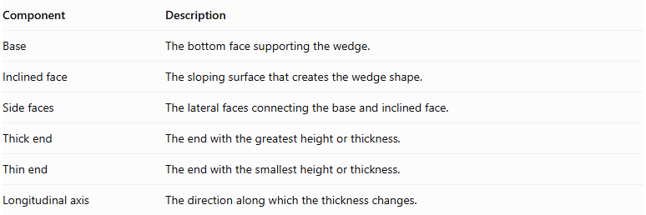
Component | Description
Base | The bottom face supporting the wedge.
Inclined face | The sloping surface that creates the wedge shape.
Side faces | The lateral faces connecting the base and inclined face.
Thick end | The end with the greatest height or thickness.
Thin end | The end with the smallest height or thickness.
Longitudinal axis | The direction along which the thickness changes.
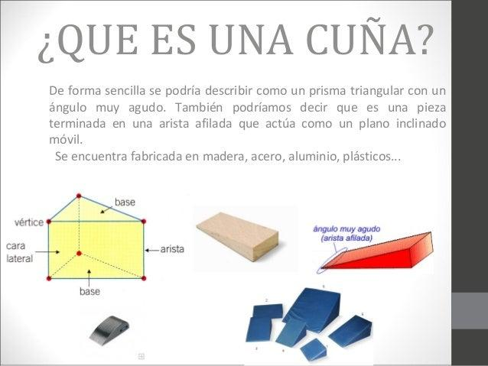

Face Structure
# Source: AI Source: Provided by: [Data Path: Persons Table -> ID Column: 1, Name_En Column: Motasem Essam] -> From: [ChatGPT] on [7/25/2026]
A common triangular wedge shaped as a triangular prism has five faces:
- Two triangular end faces.
- Three rectangular or parallelogram lateral faces.
However, other wedge constructions may have different face shapes and counts.

Edge Structure
# Source: AI Source: Provided by: [Data Path: Persons Table -> ID Column: 1, Name_En Column: Motasem Essam] -> From: [ChatGPT] on [7/25/2026]
For a triangular-prism wedge, the edges consist of:
- Three edges on the first triangular end.
- Three edges on the opposite triangular end.
- Three connecting lateral edges.
Therefore:
$$E=9$$

Vertex Structure
# Source: AI Source: Provided by: [Data Path: Persons Table -> ID Column: 1, Name_En Column: Motasem Essam] -> From: [ChatGPT] on [7/25/2026]
A triangular-prism wedge has:
- Three vertices on the first triangular end.
- Three vertices on the opposite triangular end.
Therefore:
$$V=6$$

Mathematical Properties
# Source: AI Source: Provided by: [Data Path: Persons Table -> ID Column: 1, Name_En Column: Motasem Essam] -> From: [ChatGPT] on [7/25/2026]
For a triangular-prism wedge:
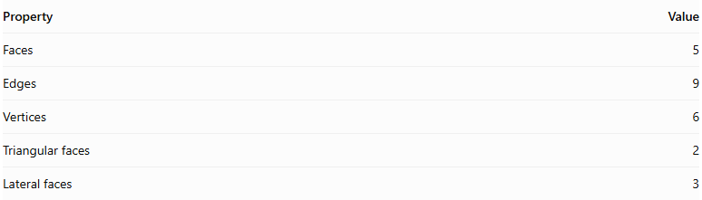
Property | Value
Faces | 5
Edges | 9
Vertices | 6
Triangular faces | 2
Lateral faces | 3
Euler's formula:
$$V-E+F=2$$
$$6-9+5=2$$

Surface Area and Volume
# Source: AI Source: Provided by: [Data Path: Persons Table -> ID Column: 1, Name_En Column: Motasem Essam] -> From: [ChatGPT] on [7/25/2026]
For a simple wedge with a triangular cross-section extended uniformly through a length $L$, the solid is a triangular prism.
Volume
If the triangular cross-section has base $b$ and height $h$:
$$V=\frac{1}{2}bhL$$
Surface Area
For a triangular cross-section with side lengths $a,b,c$:
$$SA=2A+L(a+b+c)$$
where:
$$A=\frac{1}{2}bh$$
These formulas apply to a uniform triangular-prism wedge, not every possible wedge-shaped solid.

Types of Wedges

Based on Cross-Section
# Source: AI Source: Provided by: [Data Path: Persons Table -> ID Column: 1, Name_En Column: Motasem Essam] -> From: [ChatGPT] on [7/25/2026]
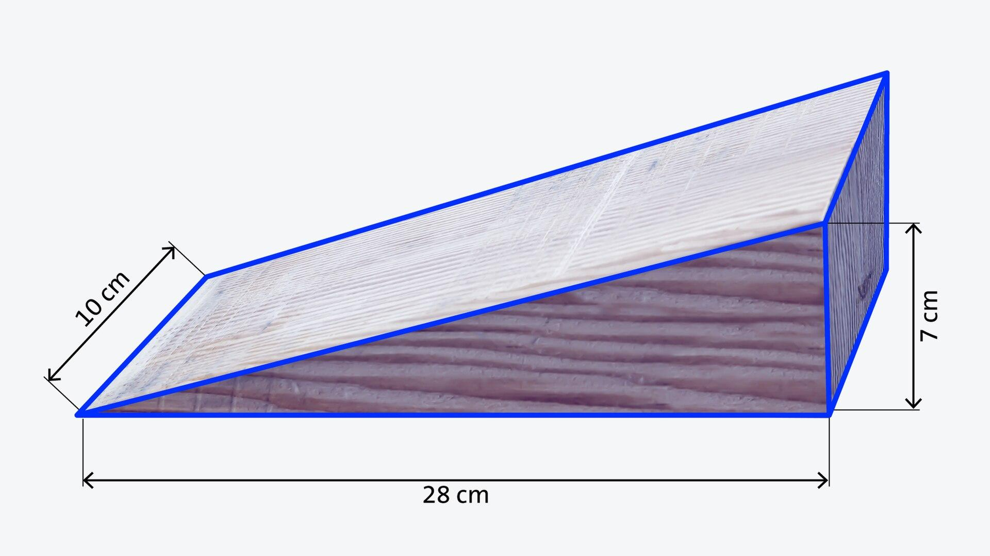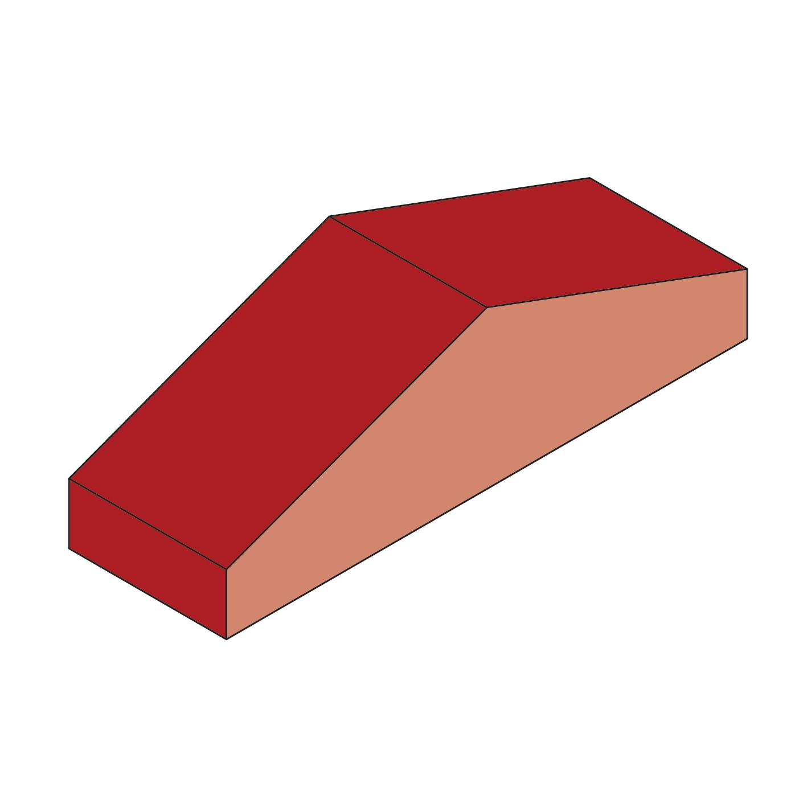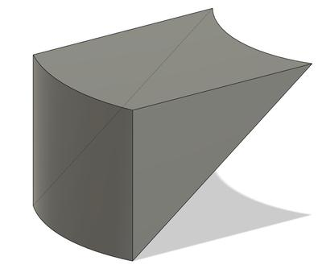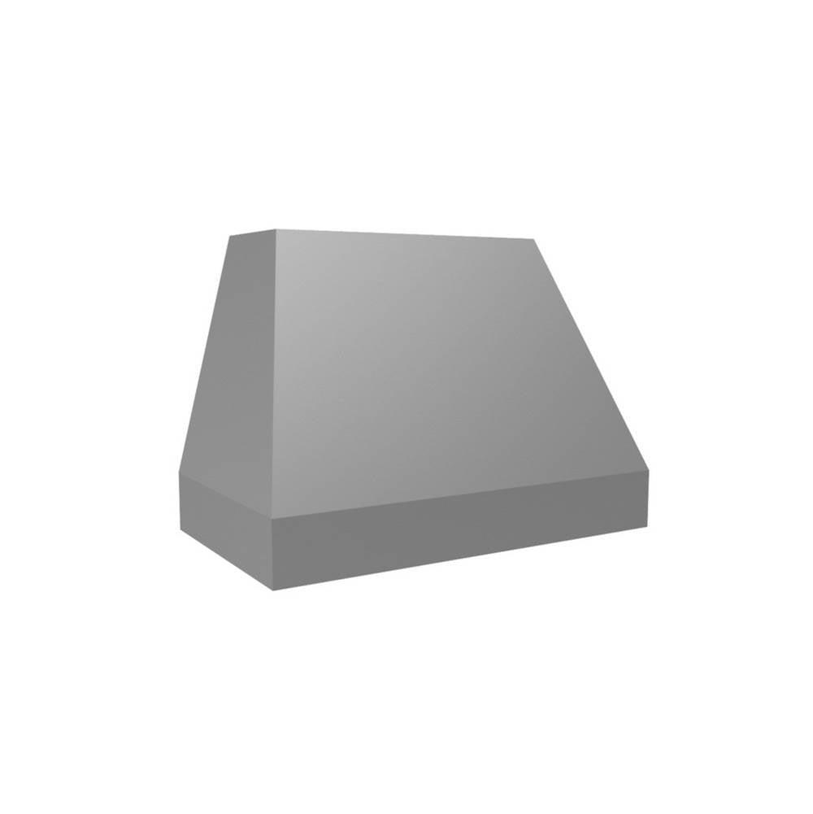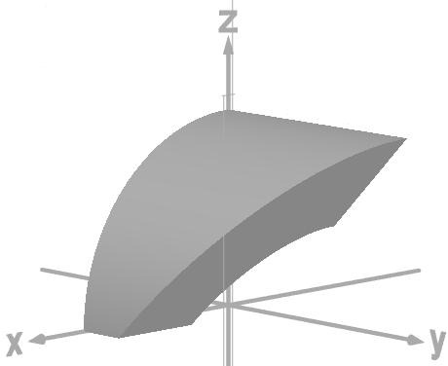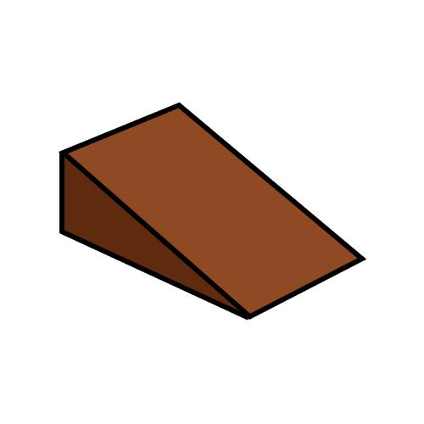
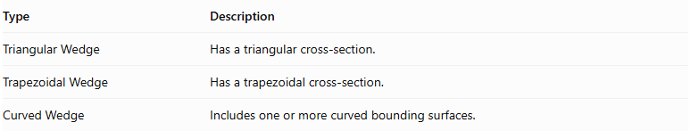
Type | Description
Triangular Wedge | Has a triangular cross-section.
Trapezoidal Wedge | Has a trapezoidal cross-section.
Curved Wedge | Includes one or more curved bounding surfaces.

Based on Inclination
# Source: AI Source: Provided by: [Data Path: Persons Table -> ID Column: 1, Name_En Column: Motasem Essam] -> From: [ChatGPT] on [7/25/2026]
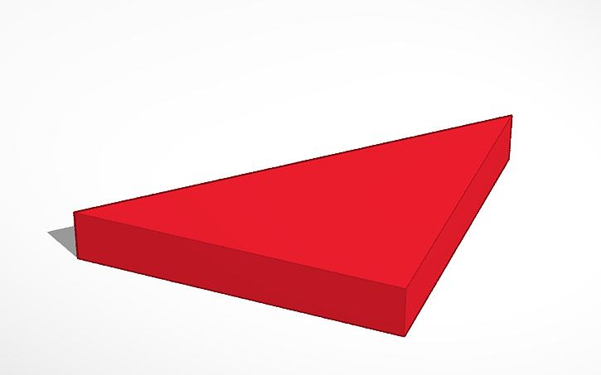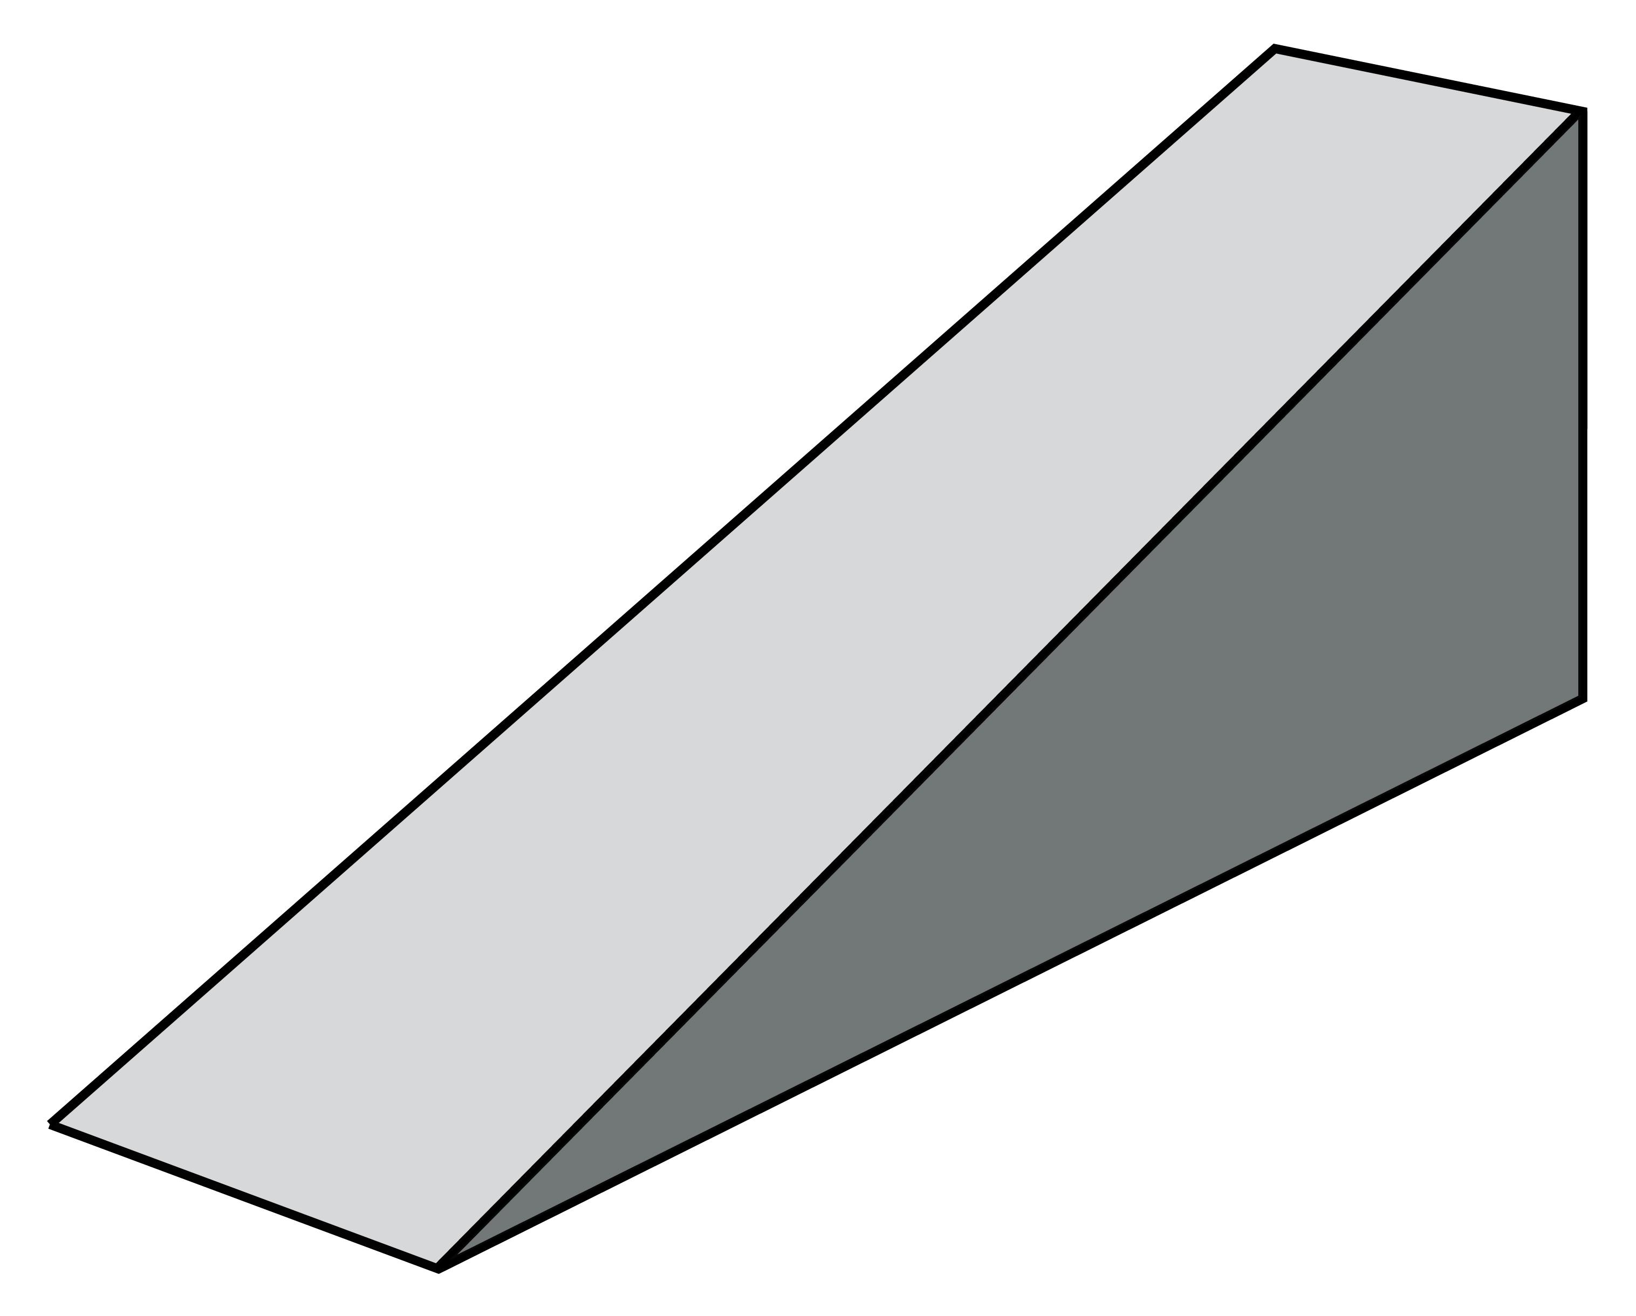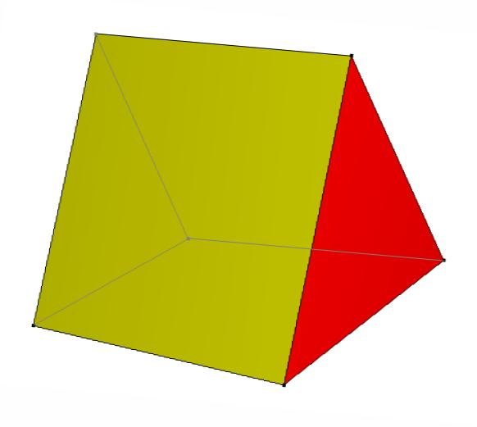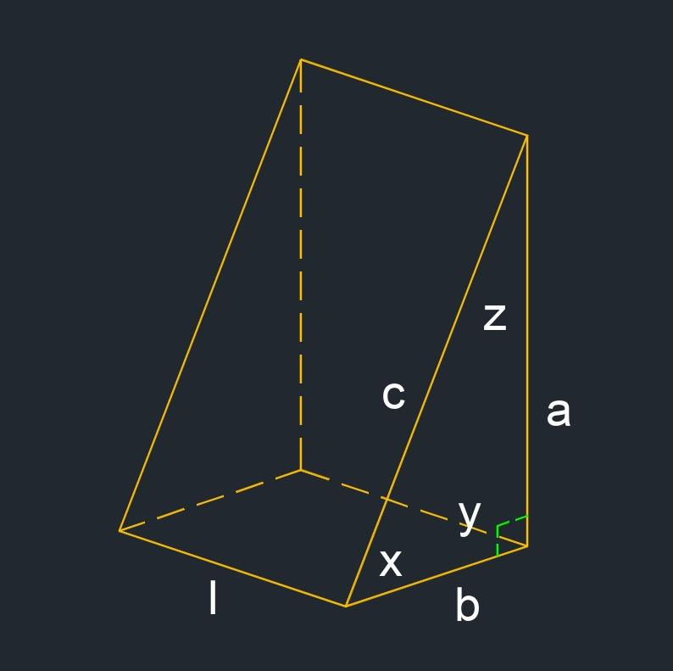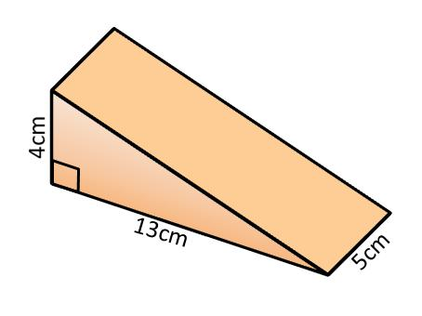
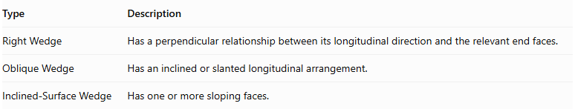
Type | Description
Right Wedge | Has a perpendicular relationship between its longitudinal direction and the relevant end faces.
Oblique Wedge | Has an inclined or slanted longitudinal arrangement.
Inclined-Surface Wedge | Has one or more sloping faces.

Constructing Wedge in Solid Geometry

Geometric Instruments Used
# Source: AI Source: Provided by: [Data Path: Persons Table -> ID Column: 1, Name_En Column: Motasem Essam] -> From: [ChatGPT] on [7/25/2026]
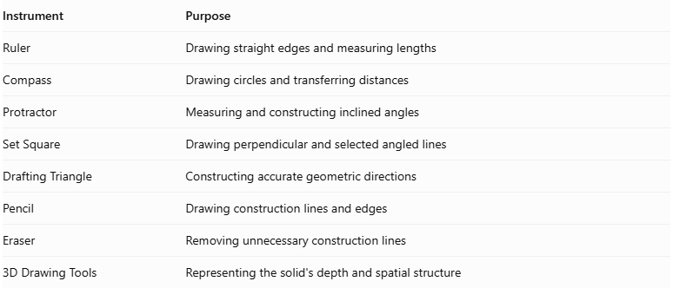
Instrument | Purpose
Ruler | Drawing straight edges and measuring lengths
Compass | Drawing circles and transferring distances
Protractor | Measuring and constructing inclined angles
Set Square | Drawing perpendicular and selected angled lines
Drafting Triangle | Constructing accurate geometric directions
Pencil | Drawing construction lines and edges
Eraser | Removing unnecessary construction lines
3D Drawing Tools | Representing the solid's depth and spatial structure

Instrument-Based Construction Procedures

Constructing a Basic Triangular Wedge
# Source: AI Source: Provided by: [Data Path: Persons Table -> ID Column: 1, Name_En Column: Motasem Essam] -> From: [ChatGPT] on [7/25/2026]
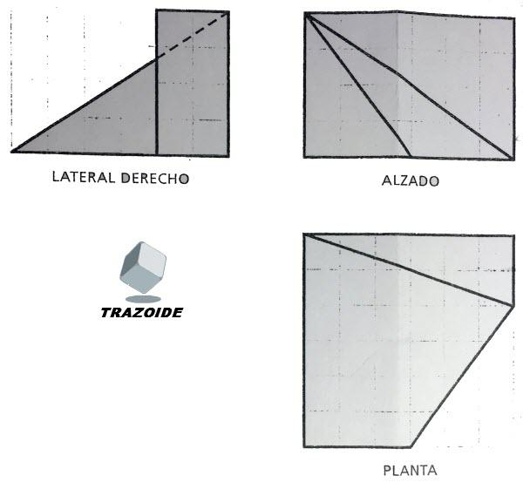
- Draw the main base using a ruler.
- Mark the required length and width of the solid.
- Draw the triangular end profile using a ruler and protractor.
- Construct the second end profile parallel to the first, where the selected wedge design requires it.
- Connect corresponding vertices using straight lines.
- Draw the inclined face connecting the appropriate edges.
- Distinguish visible edges from hidden edges.
- Erase unnecessary construction lines and finalize the drawing.

Constructing a Wedge by Cutting a Prism
# Source: AI Source: Provided by: [Data Path: Persons Table -> ID Column: 1, Name_En Column: Motasem Essam] -> From: [ChatGPT] on [7/25/2026]
- Construct a prism using geometric instruments.
- Identify the intended cutting plane.
- Draw the inclined cutting line on the appropriate side view.
- Extend the cutting plane across the prism's relevant faces.
- Identify the intersection points between the cutting plane and the prism edges.
- Connect the intersection points to represent the cut surface.
- Remove or omit the portion outside the wedge.
- Complete the visible and hidden edges of the remaining solid.

Constructing a Wedge by Joining Geometric Faces
# Source: AI Source: Provided by: [Data Path: Persons Table -> ID Column: 1, Name_En Column: Motasem Essam] -> From: [ChatGPT] on [7/25/2026]
- Draw the base polygon.
- Construct the required triangular or polygonal end profile.
- Draw the inclined side boundaries.
- Connect the corresponding boundary points.
- Complete the lateral faces.
- Check that the faces meet consistently along their shared edges.
- Finalize the three-dimensional representation.
Construction note: These procedures use physical geometric instruments and geometric relationships. They are not coordinate-based construction methods.

Relationship to Other Solids
# Source: AI Source: Provided by: [Data Path: Persons Table -> ID Column: 1, Name_En Column: Motasem Essam] -> From: [ChatGPT] on [7/25/2026]
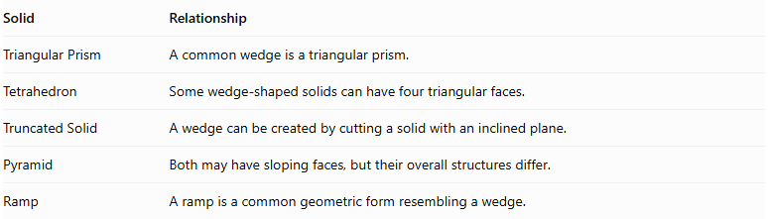
Solid | Relationship
Triangular Prism | A common wedge is a triangular prism.
Tetrahedron | Some wedge-shaped solids can have four triangular faces.
Truncated Solid | A wedge can be created by cutting a solid with an inclined plane.
Pyramid | Both may have sloping faces, but their overall structures differ.
Ramp | A ramp is a common geometric form resembling a wedge.

Key Points
# Source: AI Source: Provided by: [Data Path: Persons Table -> ID Column: 1, Name_En Column: Motasem Essam] -> From: [ChatGPT] on [7/25/2026]
- A wedge is a three-dimensional solid with a characteristic sloping shape.
- It commonly has a thick end and a thin end.
- A triangular-prism wedge has 5 faces, 9 edges, and 6 vertices.
- Wedges can have polygonal or curved surfaces.
- The exact formulas depend on the wedge's geometric construction.
- Not every wedge is a triangular prism.

Conclusion
# Source: AI Source: Provided by: [Data Path: Persons Table -> ID Column: 1, Name_En Column: Motasem Essam] -> From: [ChatGPT] on [7/25/2026]
A Wedge is a solid characterized by a gradual change in thickness and one or more inclined surfaces. It can be constructed from triangular, trapezoidal, or curved cross-sections.
Classification note: For your Solid Geometry taxonomy, distinguish Triangular-Prism Wedges, Tetrahedral Wedges, and Curved Wedges rather than treating every wedge as the same solid.

